JavaScript Tutorial
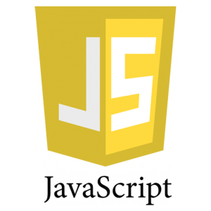
Our JavaScript Tutorial is designed for beginners and professionals both. JavaScript is used to create client-side dynamic pages.
JavaScript is an object-based scripting language which is lightweight and cross-platform.
JavaScript is not a compiled language, but it is a translated language. The JavaScript Translator (embedded in the browser) is responsible for translating the JavaScript code for the web browser.

What is JavaScript
JavaScript (js) is a light-weight object-oriented programming language which is used by several websites for scripting the webpages. It is an interpreted, full-fledged programming language that enables dynamic interactivity on websites when applied to an HTML document. It was introduced in the year 1995 for adding programs to the webpages in the Netscape Navigator browser. Since then, it has been adopted by all other graphical web browsers. With JavaScript, users can build modern web applications to interact directly without reloading the page every time. The traditional website uses js to provide several forms of interactivity and simplicity.
Although, JavaScript has no connectivity with Java programming language. The name was suggested and provided in the times when Java was gaining popularity in the market. In addition to web browsers, databases such as CouchDB and MongoDB uses JavaScript as their scripting and query language.

Features of JavaScript
There are following features of JavaScript:
- All popular web browsers support JavaScript as they provide built-in execution environments.
- JavaScript follows the syntax and structure of the C programming language. Thus, it is a structured programming language.
- JavaScript is a weakly typed language, where certain types are implicitly cast (depending on the operation).
- JavaScript is an object-oriented programming language that uses prototypes rather than using classes for inheritance.
- It is a light-weighted and interpreted language.
- It is a case-sensitive language.
- JavaScript is supportable in several operating systems including, Windows, macOS, etc.
- It provides good control to the users over the web browsers.

History of JavaScript
In 1993, Mosaic, the first popular web browser, came into existence. In the year 1994, Netscape was founded by Marc Andreessen. He realized that the web needed to become more dynamic. Thus, a 'glue language' was believed to be provided to HTML to make web designing easy for designers and part-time programmers. Consequently, in 1995, the company recruited Brendan Eich intending to implement and embed Scheme programming language to the browser. But, before Brendan could start, the company merged with Sun Microsystems for adding Java into its Navigator so that it could compete with Microsoft over the web technologies and platforms. Now, two languages were there: Java and the scripting language. Further, Netscape decided to give a similar name to the scripting language as Java's. It led to 'Javascript'. Finally, in May 1995, Marc Andreessen coined the first code of Javascript named 'Mocha'. Later, the marketing team replaced the name with 'LiveScript'. But, due to trademark reasons and certain other reasons, in December 1995, the language was finally renamed to 'JavaScript'. From then, JavaScript came into existence.

Application of JavaScript
JavaScript is used to create interactive websites. It is mainly used for:
- Client-side validation,
- Dynamic drop-down menus,
- Displaying date and time,
- Displaying pop-up windows and dialog boxes (like an alert dialog box, confirm dialog box and prompt dialog box),
- Displaying clocks etc.

JavaScript Example
- <script>
- document.write("Hello JavaScript by JavaScript");
- </script>

Javascript Data Types
JavaScript provides different data types to hold different types of values. There are two types of data types in JavaScript.
- Primitive data type
- Non-primitive (reference) data type
JavaScript is a dynamic type language, means you don't need to specify type of the variable because it is dynamically used by JavaScript engine. You need to use var here to specify the data type. It can hold any type of values such as numbers, strings etc. For example:
- var a=40;//holding number
- var b="Rahul";//holding string

JavaScript primitive data types
There are five types of primitive data types in JavaScript. They are as follows:
Data Type | Description
String | represents sequence of characters e.g. "hello"
Number | represents numeric values e.g. 100
Boolean | represents boolean value either false or true
Undefined | represents undefined value
Null | represents null i.e. no value at all

JavaScript non-primitive data types
The non-primitive data types are as follows:
Data Type | Description
Object | represents instance through which we can access members
Array | represents group of similar values
RegExp | represents regular expression
We will have great discussion on each data type later.

JavaScript Operators
JavaScript operators are symbols that are used to perform operations on operands. For example:
- var sum=10+20;
Here, + is the arithmetic operator and = is the assignment operator.
There are following types of operators in JavaScript.
- Arithmetic Operators
- Comparison (Relational) Operators
- Bitwise Operators
- Logical Operators
- Assignment Operators
- Special Operators

JavaScript Arithmetic Operators
Arithmetic operators are used to perform arithmetic operations on the operands. The following operators are known as JavaScript arithmetic operators.
Operator | Description | Example
+ | Addition | 10+20 = 30
- | Subtraction | 20-10 = 10
* | Multiplication | 10*20 = 200
/ | Division | 20/10 = 2
% | Modulus (Remainder) | 20%10 = 0
++ | Increment | var a=10; a++; Now a = 11
-- | Decrement | var a=10; a--; Now a = 9

JavaScript Comparison Operators
The JavaScript comparison operator compares the two operands. The comparison operators are as follows:
Operator | Description | Example
== | Is equal to | 10==20 = false
=== | Identical (equal and of same type) | 10==20 = false
!= | Not equal to | 10!=20 = true
!== | Not Identical | 20!==20 = false
> | Greater than | 20>10 = true
>= | Greater than or equal to | 20>=10 = true
< | Less than | 20<10 = false
<= | Less than or equal to | 20<=10 = false

JavaScript Bitwise Operators
The bitwise operators perform bitwise operations on operands. The bitwise operators are as follows:
Operator | Description | Example
& | Bitwise AND | (10==20 & 20==33) = false
| | Bitwise OR | (10==20 | 20==33) = false
^ | Bitwise XOR | (10==20 ^ 20==33) = false
~ | Bitwise NOT | (~10) = -10
<< | Bitwise Left Shift | (10<<2) = 40
>> | Bitwise Right Shift | (10>>2) = 2
>>> | Bitwise Right Shift with Zero | (10>>>2) = 2

JavaScript Logical Operators
The following operators are known as JavaScript logical operators.
Operator | Description | Example
&& | Logical AND | (10==20 && 20==33) = false
|| | Logical OR | (10==20 || 20==33) = false
! | Logical Not | !(10==20) = true

JavaScript Assignment Operators
The following operators are known as JavaScript assignment operators.
Operator | Description | Example
= | Assign | 10+10 = 20
+= | Add and assign | var a=10; a+=20; Now a = 30
-= | Subtract and assign | var a=20; a-=10; Now a = 10
*= | Multiply and assign | var a=10; a*=20; Now a = 200
/= | Divide and assign | var a=10; a/=2; Now a = 5
%= | Modulus and assign | var a=10; a%=2; Now a = 0

JavaScript Special Operators
The following operators are known as JavaScript special operators.
Operator | Description
(?:) | Conditional Operator returns value based on the condition. It is like if-else.
, | Comma Operator allows multiple expressions to be evaluated as single statement.
delete | Delete Operator deletes a property from the object.
in | In Operator checks if object has the given property
instanceof | checks if the object is an instance of given type
new | creates an instance (object)
typeof | checks the type of object.
void | it discards the expression's return value.
yield | checks what is returned in a generator by the generator's iterator.
Next TopicJavaScript If-else Statement

JavaScript If-else
The JavaScript if-else statement is used to execute the code whether condition is true or false. There are three forms of if statement in JavaScript.
- If Statement
- If else statement
- if else if statement

JavaScript If statement
It evaluates the content only if expression is true. The signature of JavaScript if statement is given below.
- if(expression){
- //content to be evaluated
- }

Flowchart of JavaScript If statement
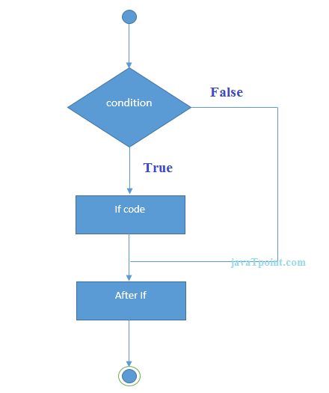
Let’s see the simple example of if statement in javascript.
- <script>
- var a=20;
- if(a>10){
- document.write("value of a is greater than 10");
- }
- </script>
Test it Now

Output of the above example
value of a is greater than 10

JavaScript If...else Statement
It evaluates the content whether condition is true of false. The syntax of JavaScript if-else statement is given below.
- if(expression){
- //content to be evaluated if condition is true
- }
- else{
- //content to be evaluated if condition is false
- }

Flowchart of JavaScript If...else statement
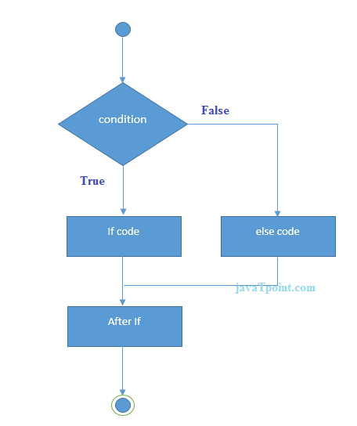
Let’s see the example of if-else statement in JavaScript to find out the even or odd number.
- <script>
- var a=20;
- if(a%2==0){
- document.write("a is even number");
- }
- else{
- document.write("a is odd number");
- }
- </script>
Test it Now

Output of the above example
a is even number

JavaScript If...else if statement
It evaluates the content only if expression is true from several expressions. The signature of JavaScript if else if statement is given below.
- if(expression1){
- //content to be evaluated if expression1 is true
- }
- else if(expression2){
- //content to be evaluated if expression2 is true
- }
- else if(expression3){
- //content to be evaluated if expression3 is true
- }
- else{
- //content to be evaluated if no expression is true
- }
Let’s see the simple example of if else if statement in javascript.
- <script>
- var a=20;
- if(a==10){
- document.write("a is equal to 10");
- }
- else if(a==15){
- document.write("a is equal to 15");
- }
- else if(a==20){
- document.write("a is equal to 20");
- }
- else{
- document.write("a is not equal to 10, 15 or 20");
- }
- </script>
Test it Now

Output of the above example

JavaScript Switch
The JavaScript switch statement is used to execute one code from multiple expressions. It is just like else if statement that we have learned in previous page. But it is convenient than if..else..if because it can be used with numbers, characters etc.
The signature of JavaScript switch statement is given below.
- switch(expression){
- case value1:
- code to be executed;
- break;
- case value2:
- code to be executed;
- break;
- ......

- default:
- code to be executed if above values are not matched;
- }
Let’s see the simple example of switch statement in javascript.
- <script>
- var grade='B';
- var result;
- switch(grade){
- case 'A':
- result="A Grade";
- break;
- case 'B':
- result="B Grade";
- break;
- case 'C':
- result="C Grade";
- break;
- default:
- result="No Grade";
- }
- document.write(result);
- </script>
Test it Now

Output of the above example
B Grade

The switch statement is fall-through i.e. all the cases will be evaluated if you don't use break statement.
Let’s understand the behaviour of switch statement in JavaScript.
- <script>
- var grade='B';
- var result;
- switch(grade){
- case 'A':
- result+=" A Grade";
- case 'B':
- result+=" B Grade";
- case 'C':
- result+=" C Grade";
- default:
- result+=" No Grade";
- }
- document.write(result);
- </script>

JavaScript Loops
The JavaScript loops are used to iterate the piece of code using for, while, do while or for-in loops. It makes the code compact. It is mostly used in array.
There are four types of loops in JavaScript.
- for loop
- while loop
- do-while loop
- for-in loop

1) JavaScript For loop
The JavaScript for loop iterates the elements for the fixed number of times. It should be used if number of iteration is known. The syntax of for loop is given below.
- for (initialization; condition; increment)
- {
- code to be executed
- }
Let’s see the simple example of for loop in javascript.
- <script>
- for (i=1; i<=5; i++)
- {
- document.write(i + "<br/>")
- }
- </script>
Test it Now
Output:
1
2
3
4
5

2) JavaScript while loop
The JavaScript while loop iterates the elements for the infinite number of times. It should be used if number of iteration is not known. The syntax of while loop is given below.
- while (condition)
- {
- code to be executed
- }
Let’s see the simple example of while loop in javascript.
- <script>
- var i=11;
- while (i<=15)
- {
- document.write(i + "<br/>");
- i++;
- }
- </script>
Test it Now
Output:
11
12
13
14
15

3) JavaScript do while loop
The JavaScript do while loop iterates the elements for the infinite number of times like while loop. But, code is executed at least once whether condition is true or false. The syntax of do while loop is given below.
- do{
- code to be executed
- }while (condition);
Let’s see the simple example of do while loop in javascript.
- <script>
- var i=21;
- do{
- document.write(i + "<br/>");
- i++;
- }while (i<=25);
- </script>
Test it Now
Output:
21
22
23
24
25

4) JavaScript for in loop
The JavaScript for in loop is used to iterate the properties of an object. We will discuss about it later.

Data Property
Here's an example of data property that we have been using in the previous tutorials.
const student = {

// data property
firstName: 'Monica';
};

Accessor Property
In JavaScript, accessor properties are methods that get or set the value of an object. For that, we use these two keywords:
- get - to define a getter method to get the property value
- set - to define a setter method to set the property value

JavaScript Getter
In JavaScript, getter methods are used to access the properties of an object. For example,
const student = {

// data property
firstName: 'Monica',

// accessor property(getter)
get getName() {
return this.firstName;
}
};

// accessing data property
console.log(student.firstName); // Monica

// accessing getter methods
console.log(student.getName); // Monica

// trying to access as a method
console.log(student.getName()); // error
Run Code
In the above program, a getter method getName() is created to access the property of an object.
get getName() {
return this.firstName;
}
Note: To create a getter method, the get keyword is used.
And also when accessing the value, we access the value as a property.
student.getName;
When you try to access the value as a method, an error occurs.
console.log(student.getName()); // error

JavaScript Setter
In JavaScript, setter methods are used to change the values of an object. For example,
const student = {
firstName: 'Monica',

//accessor property(setter)
set changeName(newName) {
this.firstName = newName;
}
};

console.log(student.firstName); // Monica

// change(set) object property using a setter
student.changeName = 'Sarah';

console.log(student.firstName); // Sarah
Run Code
In the above example, the setter method is used to change the value of an object.
set changeName(newName) {
this.firstName = newName;
}
Note: To create a setter method, the set keyword is used.
As shown in the above program, the value of firstName is Monica.
Then the value is changed to Sarah.
student.changeName = 'Sarah';
Note: Setter must have exactly one formal parameter.

JavaScript Object.defineProperty()
In JavaScript, you can also use Object.defineProperty() method to add getters and setters. For example,
const student = {
firstName: 'Monica'
}

// getting property
Object.defineProperty(student, "getName", {
get : function () {
return this.firstName;
}
});

// setting property
Object.defineProperty(student, "changeName", {
set : function (value) {
this.firstName = value;
}
});

console.log(student.firstName); // Monica

// changing the property value
student.changeName = 'Sarah';

console.log(student.firstName); // Sarah
Run Code
In the above example, Object.defineProperty() is used to access and change the property of an object.
The syntax for using Object.defineProperty() is:
Object.defineProperty(obj, prop, descriptor)
The Object.defineProperty() method takes three arguments.
- The first argument is the objectName.
- The second argument is the name of the property.
- The third argument is an object that describes the property.

